

**Troubleshooting Single-Area OSPFv2 and OSPFv3**

# Introduction

Open Shortest Path First (OSPF) is a link-state routing protocol for IP networks. OSPFv2 is defined for IPv4 networks, and OSPFv3 is defined for IPv6 networks. OSPFv2 and OSPFv3 are completely isolated routing protocols, changes in OSPFv2 do not affect OSPFv3 routing, and vice versa.

# Objective(s)

In this lab the student will:

* Troubleshoot Layer 3 Connectivity
* Troubleshoot OSPFv2
* Troubleshoot OSPFv3

# Equipment/Supplies Needed

If working in a physical environment:

* 3 Routers (Cisco 1941 with Cisco IOS Release 15.2(4) M3 universal image or comparable)
* 3 Cisco 2960 Switches (Software (C2960-LANBASE-M), Version 12.2)
* 3 PCs (Windows 7, Vista, or XP with terminal emulation program, such as TeraTerm)
* Console cables to configure the Cisco IOS devices via the console ports
* Ethernet and serial cables as shown in the topology

If working online:

* Your Computer workstation
* Cisco Packet Tracer (online)
* Troubleshooting Single-Area OSPFv2 and OSPFv3.pkt file

# Addressing Table

|  |  |  |  |  |
| --- | --- | --- | --- | --- |
| **Device** | **OSPF**  **Router ID** | **Interface** | **IP Address** | **Default Gateway** |
| R1 | 1.1.1.1 | G0/0 | 192.168.1.1/24  2001:DB8:ACAD:A::1/64  FE80::1 link-local | N/A |
|  |  | S0/0/0 | 192.168.12.1/30  2001:DB8:ACAD:12::1/64  FE80::1 link-local | N/A |
|  |  | S0/0/1 | 192.168.13.1/30  2001:DB8:ACAD:13::1/64  FE80::1 link-local | N/A |
| R2 | 2.2.2.2 | G0/0 | 192.168.2.1/24  2001:DB8:ACAD:B::2/64  FE80::2 link-local | N/A |
|  |  | S0/0/0 | 192.168.12.2/30  2001:DB8:ACAD:12::2/64  FE80::2 link-local | N/A |
|  |  | S0/0/1 | 192.168.23.1/30  2001:DB8:ACAD:23::2/64  FE80::2 link-local | N/A |
| R3 | 3.3.3.3 | G0/0 | 192.168.3.1/24  2001:DB8:ACAD:C::3/64  FE80::3 link-local | N/A |
|  |  | S0/0/0 | 192.168.13.2/30  2001:DB8:ACAD:13::3/64  FE80::3 link-local | N/A |
|  |  | S0/0/1 | 192.168.23.2/30  2001:DB8:ACAD:23::3/64  FE80::3 link-local | N/A |
| PC-1 |  | NIC | 192.168.1.3/24  2001:DB8:ACAD:A::A/64 | 192.168.1.1  FE80::1 |
| PC-2 |  | NIC | 192.168.2.3/24  2001:DB8:ACAD:B::B/64 | 192.168.2.1  FE80::2 |
| PC-3 |  | NIC | 192.168.3.3/24  2001:DB8:ACAD:C::C/64 | 192.168.3.1  FE80::3 |

# Topology

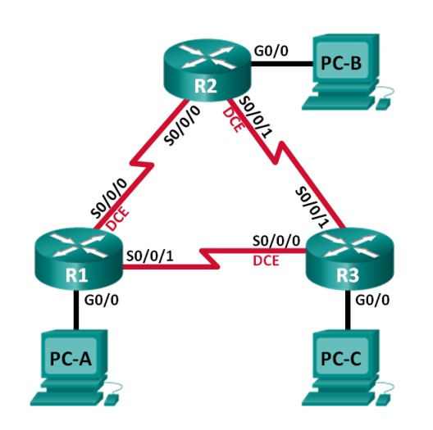

# Procedure

*Perform the steps in this lab in the order they are presented to you. Answer all questions and record the requested information in a file.*

**Note:** All routers in the provided file have the following passwords.

Privileged Exec: **security**

Console/telnet/vty: **cyber**

# Part 1: Troubleshoot Layer 3 Connectivity

In Part 1, you will verify that Layer 3 connectivity is established on all interfaces. You will need to test both IPv4 and IPv6 connectivity for all device interfaces.

**Step 1:** Verify that the interfaces listed in the Addressing Table are active and configured with the correct IP address information.

1. Issue the **show ip interface brief** command on all routers to verify that the interfaces are in an up/up state.

**Record your findings.**

1. Issue the **show interface** or **show run** command to verify IP address assignments on all router interfaces. Compare the interface IP addresses against the Addressing Table and verify the subnet mask assignments. For IPv6, verify that the link-local address has been assigned.

**Record your findings.**

Resolve all problems that are found. **Record the commands** used to correct the issues.

**Record the commands**

Using the **ping** command, verify that each router has network connectivity with the serial interfaces on the neighbor routers. Verify that the PCs can ping their default gateways. If problems still exist, continue troubleshooting Layer 3 issues.

# Part 2: Troubleshoot OSPFv2

**Step 1:** Test IPv4 end-to-end connectivity.

From each PC host, ping the other PC hosts in the topology to verify end-to-end connectivity.

1. **Ping from PC-1 to PC-2. Were the pings successful? ______yes_______**
2. **Ping from PC-1 to PC-3. Were the pings successful? ____yes_________**
3. **Ping from PC-2 to PC-3. Were the pings successful? ____No_________**

**Step 2:** Verify that all interfaces are assigned to OSPFv2 area 0 on R1

* 1. Issue the **show ip protocols** command to verify that OSPF is running and that all networks are advertised in area 0. Verify that the router ID is set correctly.

**Record your findings.**

* 1. Make the necessary changes to the configuration on R1 based on the output from the **show ip protocols** command. **Record the commands** used to correct the issues.

**Record the commands**

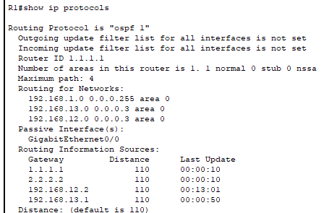

* 1. Issue the **clear ip ospf process** command if necessary.
  2. Re-issue the **show ip protocols** command, verify that your changes had the desired effect, all interfaces are listed as OSPF networks assigned to area 0 , and verify that G0/0 is a passive interface
  3. Resolve any problems discovered on R1. List any additional changes made to R1. If no problems were found on the device, then respond with “no problems were found”. No Problems were found

**Step 3:** Verify that all interfaces are assigned to OSPFv2 area 0 on R2

* 1. Issue the **show ip protocols** command to verify that OSPF is running and that all networks are being advertised in area 0. Verify that the router ID is set correctly. **Record your findings.**

* 1. Make the necessary changes to the configuration on R2 based on the output from the **show ip protocols** command. **Record the commands** used to correct the issues

**Record the commands**

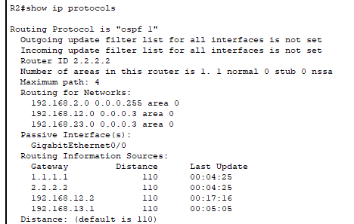

* 1. Issue the **clear ip ospf process** command if necessary.
  2. Re-issue the **show ip protocols** command to verify that your changes had the desired effect. Verify that all interfaces are listed as OSPF networks assigned to area 0 and verify that G0/0 is a passive interface.
  3. Resolve any problems discovered on R2. List any additional changes made to R2. If no problems were found on the device, then respond with “no problems were found”. Int g0/0 had the wrong link local address and int s0/0/1 was down and did not have an ipv4 address assigned

**Step 4:** Verify that all interfaces are assigned to OSPFv2 area 0 on R3.

* 1. Issue the **show ip protocols** command to verify that OSPF is running and that all networks are being advertised in area 0. Verify that the router ID is set correctly as well

**Record your findings.**

* 1. Make the necessary changes to the configuration on R3 based on the output from the **show ip protocols** command. **Record the commands** used to correct the issues.

**Record the commands**

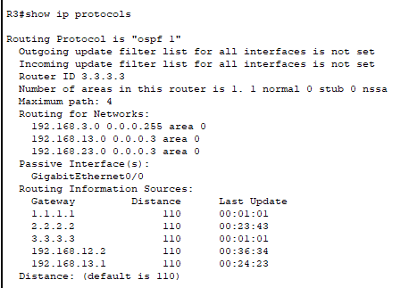

* 1. Issue the **clear ip ospf process** command if necessary.
  2. Re-issue the **show ip protocols** command to verify that your changes had the desired effect. Verify that all interfaces are listed as OSPF networks assigned to area 0 and verify that G0/0 is a passive interface.
  3. Resolve any problems discovered on R3. List any additional changes made to R3. If no problems were found on the device, then respond with “no problems were found”. Int s0/0/0 had the wrong Ipv4 address, int s0/0/1 was down , int g0/0 had no ipv4 address and was down

**Step 5:** Verify OSPF neighbor information.

1. Issue the **show ip ospf neighbor** command on all routers to view the ospf neighbor information.

**Step 6:** Verify OSPFv2 Routing Information

1. Issue the **show ip route ospf** command to verify that each router has OSPFv2 routes to all non-adjoining networks.

**Are all OSPFv2 routes available? Yes**

**If any OSPFv2 routes are missing, what is missing? none**

**Step 7:** Verify IPv4 end-to-end connectivity.

From each PC, verify that IPv4 end-to-end connectivity exists. PCs should be able to ping the other PC hosts in the topology. If IPv4 end-to-end connectivity does not exist, then continue troubleshooting to resolve any remaining issues.

# Part 3: Troubleshoot OSPFv3

In Part 4, you will troubleshoot OSPFv3 problems and make the necessary changes needed to establish OSPFv3 routes and end-to-end IPv6 connectivity.

**Note:** LAN (G0/0) interfaces should not advertise OSPFv3 routing information, but routes to these networks should be contained in the routing tables.

**Step 1:** Test IPv6 end-to-end connectivity.

From each PC host, ping the IPv6 addresses of the other PC hosts in the topology to verify IPv6 end-to-end connectivity.

**Step 2:** Verify that IPv6 unicast routing has been enabled on all routers

1. An easy way to verify that IPv6 routing has been enabled on a router is to use the **show run** and look for the **ipv6 unicast-routing** command. The **ipv6 unicast-routing** command displays if IPv6 routing has been enabled.
2. If IPv6 unicast routing is not enabled on one or more routers, enable it now. Record the commands used to correct the issues.

**Step 3:** Verify that all interfaces are assigned to OSPFv3 area 0 on R1

1. Issue the **show ipv6 protocols** command and verify that the router ID is correct. Also verify that the expected interfaces are displayed under area 0.

**Note:** If no output is generated from this command, then the OSPFv3 process has not been configured. Record your findings.

1. Make the necessary configuration changes to R1. **Record the commands** used to correct the issues.

**Record the commands**

1. Issue the **clear ipv6 ospf** process command if necessary
2. Re-issue the **show ipv6 protocols** command to verify that your changes had the desired effect.
3. Verify that all interfaces are listed as OSPF networks assigned to area 0. Verify that the G0/0 interface is set not to advertise.
4. Resolve any problems discovered on R1. List any additional changes made to R1. If no problems were found on the device, then respond with “no problems were found”. No problems found

**Step 4:** Verify that all interfaces are assigned to OSPFv3 area 0 on R2.

1. Issue the **show ipv6 protocols** command and verify the router ID is correct. Also verify that the expected interfaces display under area 0.

**Note:** If no output is generated from this command, then the OSPFv3 process has not been configured.

**Record your findings.**

1. Make the necessary configuration changes to R2. Record the commands used to correct the issues

1. Issue the **clear ipv6 ospf process** command if necessary.
2. Re-issue the **show ipv6 protocols** command to verify that your changes had the desired effect.
3. Verify that all interfaces are listed as OSPF networks assigned to area 0. Verify that the G0/0 interface is set not to advertise.
4. Resolve any problems discovered on R2. List any additional changes made to R2. If no problems were found on the device, then respond with “no problems were found”. No problems were found
5. List any additional changes made to R2. If no problems were found on the device, then respond with “no problems were found”. No Problems were found

**Step 5:** Verify that all interfaces are assigned to OSPFv3 area 0 on R3

1. Issue the **show ipv6 protocols** command and verify that the router ID is correct.

Also verify that the expected interfaces display under area 0.

**Note:** If no output is generated from this command, then the OSPFv3 process has not been configured.

**Record your findings**

1. Make the necessary configuration changes to R3. **Record the commands** used to correct the issues.

**Record the commands**

1. Issue the **clear ipv6 ospf process** command if necessary.
2. Re-issue the **show ipv6 protocols** command to verify that your changes had the desired effect.
3. Verify that all interfaces are listed as OSPF networks assigned to area 0. Verify that the G0/0 interface is set not to advertise.
4. Resolve any problems discovered on R3. List any additional changes made to R3. If no problems were found on the device, then respond with “no problems were found”. no problems were found
5. List any additional changes made to R3. If no problems were found on the device, then respond with “no problems were found”. no problems were found

**Step 6:** Verify that all routers have correct neighbor adjacency information

1. Issue the **show ipv6 ospf neighbor** command to verify that adjacencies have formed between neighboring routers.
2. Resolve any OSPFv3 adjacency issues that still exist **Step 7:** Verify OSPFv3 routing information.

a. Issue the **show ipv6 route ospf** command, and verify that OSPFv3 routes exist to all non-adjoining networks

# Questions

**Are all OSPFv3 routes available? yes**

**If any OSPFv3 routes are missing, what is missing? no**

b. Resolve any routing issues that still exist.

**Step 8:** Verify IPv6 end-to-end connectivity.

From each PC, verify that IPv6 end-to-end connectivity exists. PCs should be able to ping each interface on the network. If IPv6 end-to-end connectivity does not exist, then continue troubleshooting to resolve remaining issues.

**Reflection**

**Why would you troubleshoot OSPFv2 and OSPFv3 separately? Troubleshooting OSPFv2 and OSPFv3 separately ensures that the specific characteristics and requirements of each protocol version are addressed properly**

**Submit Your Work:**

Submit all text files, screenshots, or answers to questions to your instructor Using the most appropriate method below.

Packet Tracer:

Submit Packet Tracer file as well as your text file with your findings and notes.

# Rubric

Checklist/Single Point Mastery

|  |  |  |
| --- | --- | --- |
| Concerns  Working Towards Proficiency | Criteria  Standards for This Competency | Accomplished  Evidence of Mastering Competency |
|  | Criteria #1:Verify that all interfaces are assigned to  OSPFv2 area 0 on R1(10 pts) | Discover issue on Router 1 and correct the problem. (OSPFv2) (10 pts) |
|  | Criteria #2: Discover issue on  Router 2 and correct the problem (OSPFv2) (10 pts) | Discover issue on Router 2 and correct the problem (OSPFv2) (10 pts) |
|  | Criteria #3: Discover issue on  Router 3 and correct the problem (OSPFv2) (10 pts) | Discover issue on Router 3 and correct the problem (OSPFv2) (10 pts) |
|  | Criteria #4: Verify that IPv6 unicast routing has been enabled on all routers (10 pts) | Verify that IPv6 unicast routing has been enabled on all routers (10 pts) |
|  | Criteria #5: Verify that all interfaces are assigned to  OSPFv3 area 0 on R3 (10 pts) | Verify that all interfaces are assigned to OSPFv3 area 0 on R3 (10 pts) |
|  | Criteria #6: Test connectivity between all remote networks using ping. (10 pts) | Test connectivity between all remote networks using ping. (10 pts)  3 remote networks (3.3 pts) |
|  | Criteria #7: Submit instructions document with lab questions and  documentation completed. (40 pts) | Criteria #5: Submit instructions document with lab questions and documentation completed.(40 pts) |